**CSS Notes**

1. Lego structure
   1. In body create div with id container
   2. In container create header and main tags
   3. In main create div’s with id row-1 and row-2
   4. In row-2 create three div’s without an id

<body>

<div id="container">

<!-- top of page -->

<header>

<!-- ... -->

</header> <!-- header -->

<!-- main container -->

<main>

<div id="row-1">

<!-- upper-left image -->

<img src="img.jpg" alt="img not found">

<!-- <div class="row-1">

</div> <!-- row-1 -->

<!-- upper-right box -->

<div>

</div> <!-- end upper-right box -->

</div> <!-- row-1 -->

<div id="row-2">

<div> </div>

<div> </div>

<div> </div>

</div> <!-- row-2 -->

</main> <!-- end main-container -->

</div> <!-- container -->

</body>

1. Transparency:
   1. In content add the following:

#container {

/* background: red; */

height: 1000px;

width: 1013px;

/* DEBUG */

background-image: url("spec.png");

background-size: contain;

background-repeat: no-repeat;

}

1. Position blocks on same line (within a row-div)

display: inline-block;

vertical-align: top;

1. Columns in second row:
   1. Start with a row with three 100x100 blocks

/* ------------------------------------------------------------------ */

#row-2 {

/* DEBUG */

background: yellow;

opacity: 0.5;

height: 600px;

}

#row-2 div {

background: red;

height: 100px;

width: 100px;

margin-top: 5px;

margin-right: 5px;

margin-left: 5px;

display: inline-block;

vertical-align: top;

/* DEBUG */

opacity: 0.5;

}

/* ------------------------------------------------------------------ */

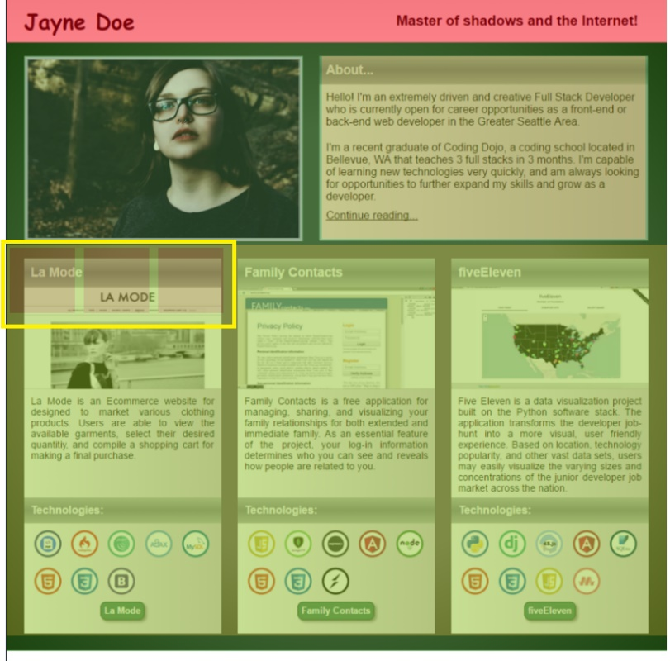

* 1. Adjust margin-left to get the first block into left column

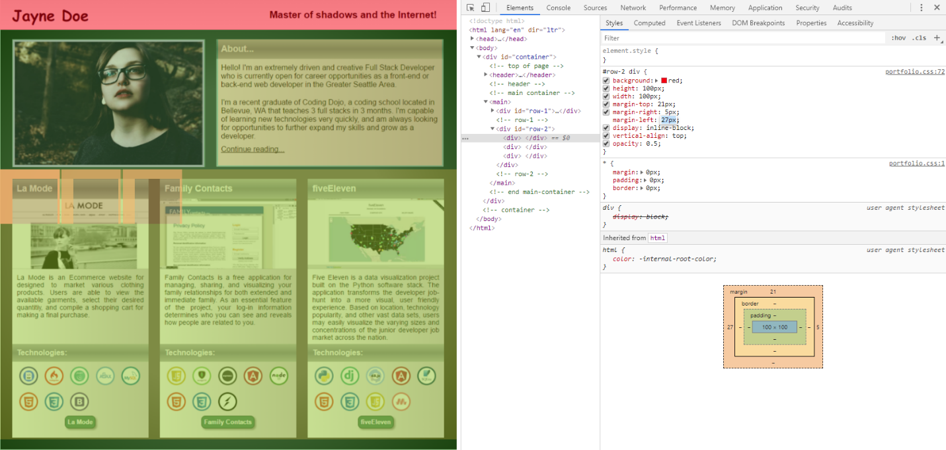

* 1. Adjust height and width

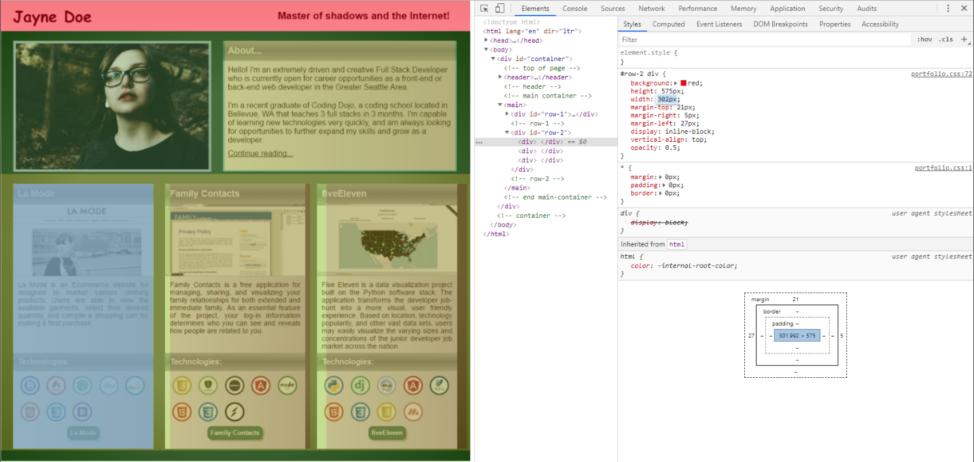

* 1. Adjust margin-right to separate the three blocks appropriately

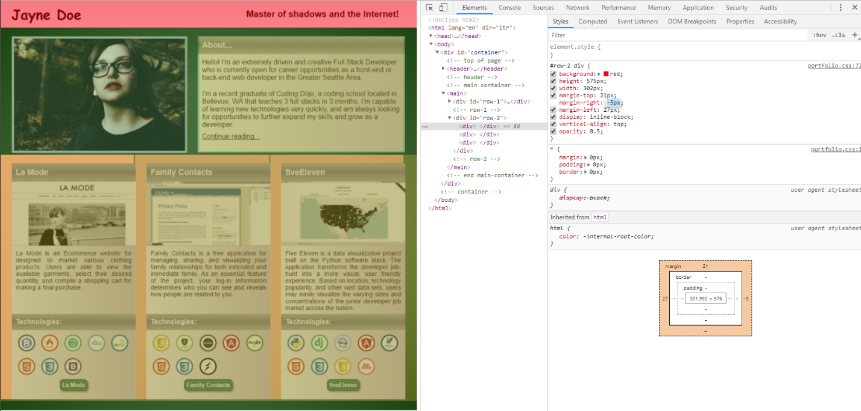

* 1. Add in two row in each column

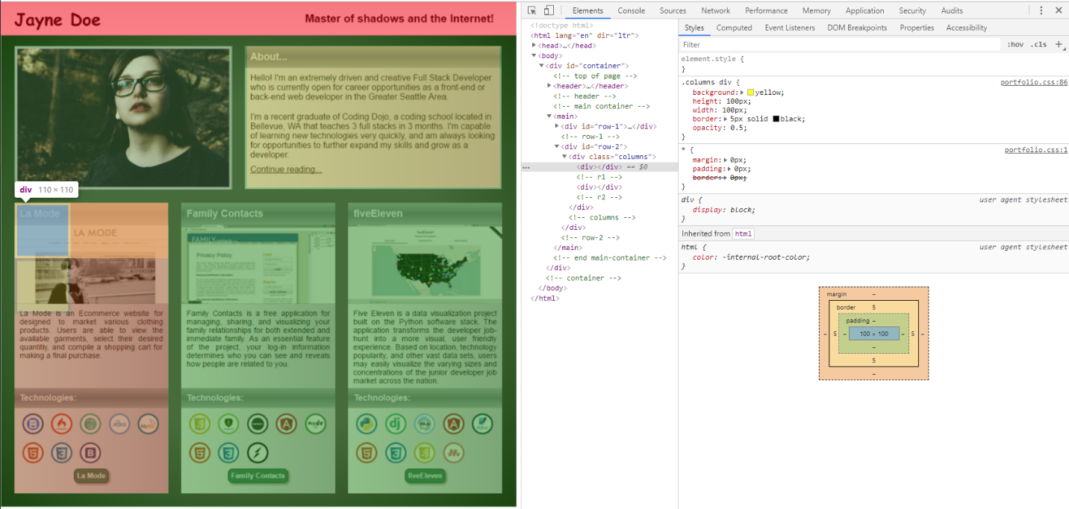

* 1. Increase height of first row

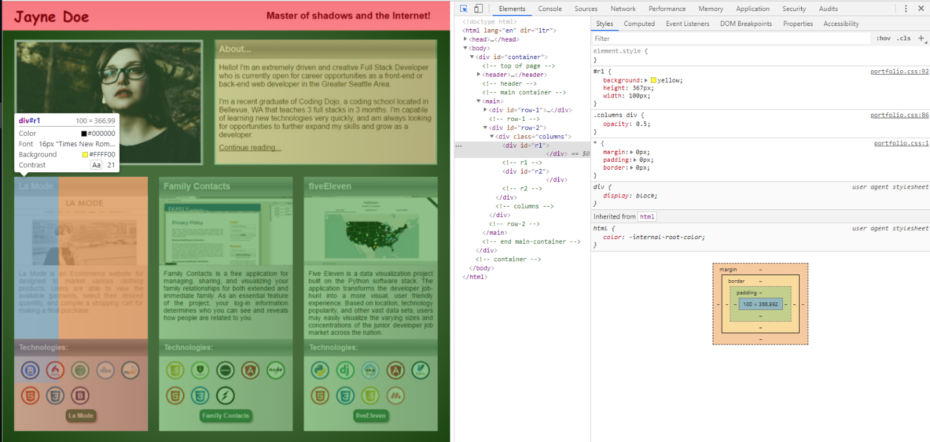

* 1. Increase height of second row
  2. Increase width of both rows in col

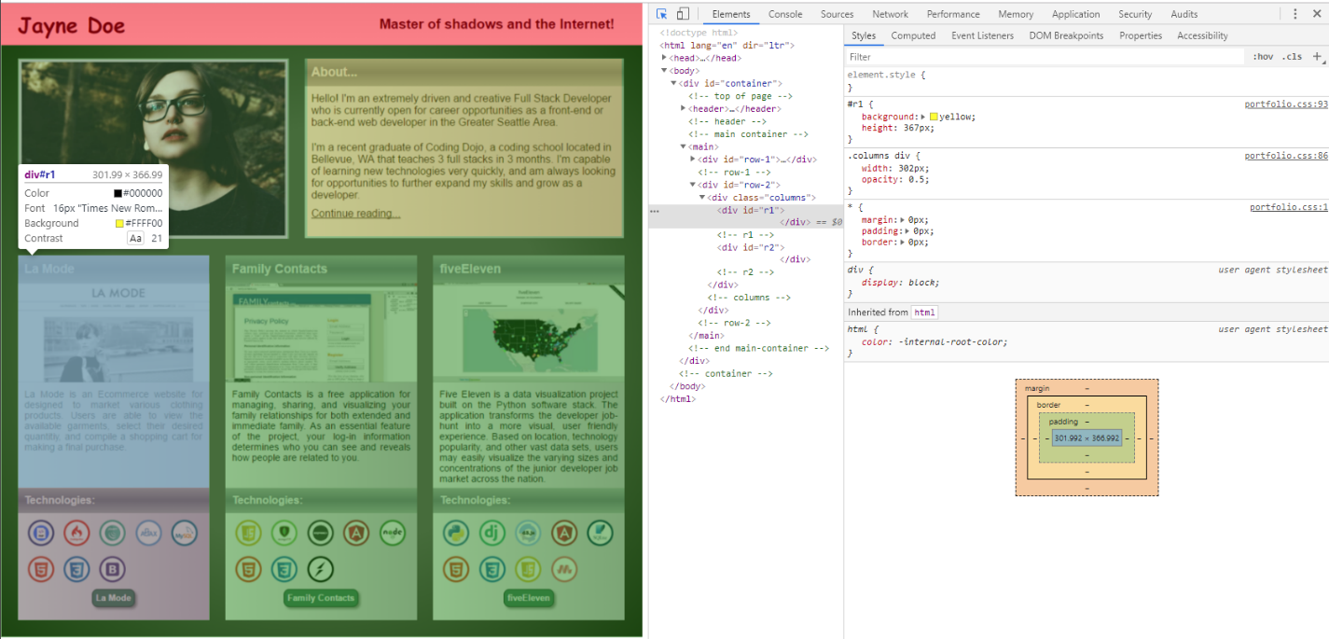

* 1. Add in text at top of first column top box and adjust margin on all sides.

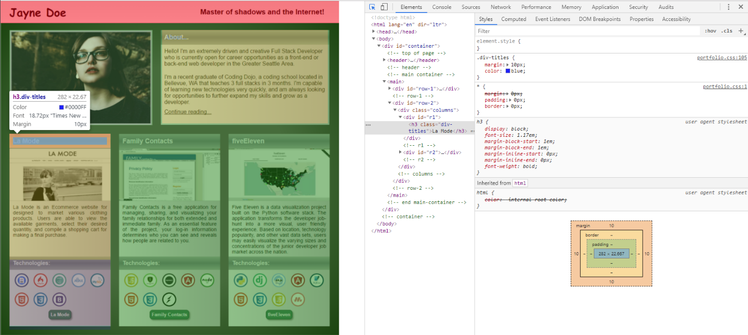

* 1. Add gradient to text and adjust height and **padding** of text

.div-titles-text {

background-image: linear-gradient(#B4B4B7, #888894, #B3B3B5);

height: 25px;

margin-top: 0px;

padding: 10px

}

* 1. Repeat for Technologies text
  2. Repeat for About text
  3. Add in images in columns
  4. Add in gradient to background
  5. .

1. .

A

B

c